Exercise no: 3 regno:1518102098

Date:15.10.20

**Aim**

To write a Python program to remove and print every second number from a list of numbers until the list becomes empty.

**Program**

def removeThirdnumber(lst):

temp=[]

p=1

s=0

for i in range(0,len(lst)):

s=(p+s)%len(lst)

re=lst.pop(s)

temp.append(re)

return temp

n=int(input())

lst=[]

for i in range(0,n):

lst.append(int(input()))

p=removeThirdnumber(lst)

print(p)

**Link**

http://103.53.53.18/mod/vpl/forms/edit.php?id=231&userid=1703

**output**

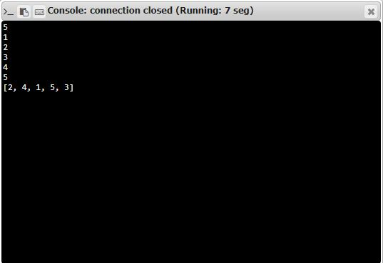

**Result**

Thus,the code has been sucessfully executed and output is verified.